LAB ASSIGNMENT 10.2
Name: V. Rajeev Kalyan
Hall Ticket: 2403a51324
Batch: 13
Task Description#1 AI-Assisted Code Review (Basic Errors):

Prompt: I have written a Python program but it may contain mistakes in logic, syntax, indentation, variable naming, or unused variables. Please carefully review my code, identify all problems, explain why they are problems, and then rewrite the entire program in a corrected form with clear comments showing the changes you made.
ERROR CODE:
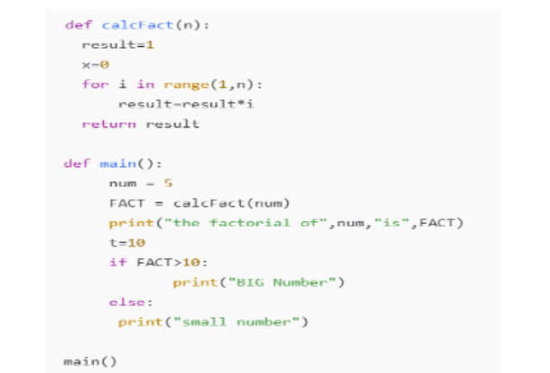

Issues Found:
Python program for calculating the factorial has several issues that prevent it from working as intended. The loop in the factorial function uses range(1, n) which stops at n-1 and therefore does not include the last multiplication, producing an incorrect factorial. There are unused variables such as x and t that add confusion and should be removed to keep the code clean. The else statement is misaligned with the if statement, which can trigger an indentation error. Variable naming such as FACT suggests a constant, but it is actually a changing value, so a lowercase name would be more appropriate. The print statement could also be improved using an f-string to make the output clearer. Fixing these issues by adjusting the loop to range(1, n+1), removing unused variables, correcting the indentation, and improving naming and output formatting will produce a clean, working program that correctly calculates and displays the factorial.
CORRECTED CODE:
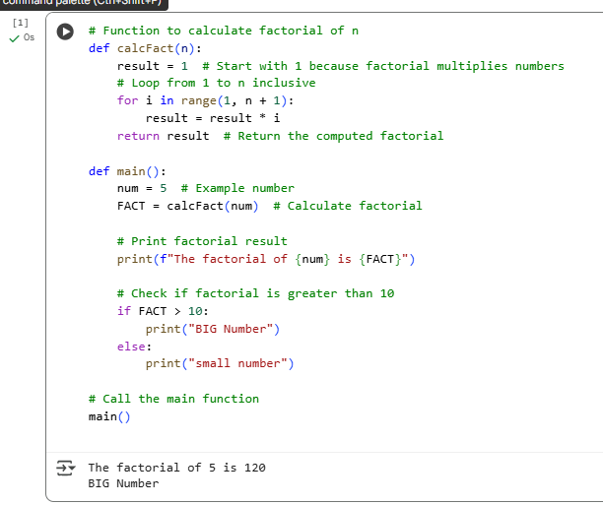
Observation:
The program attempts to calculate the factorial of a number but contains several issues. The for loop uses range(1, n) and therefore misses multiplying by n, leading to an incorrect factorial result. Variables such as x and t are declared but never used, which clutters the code. The else block is not properly indented with the if statement, potentially causing an indentation error. Variable naming (like FACT) is inconsistent with Python conventions, and the print statement could be more readable using an f-string. These issues affect both the accuracy and the clarity of the program.
Task Description#2 Automatic Inline Comments:
Prompt:
I have written the following Python code for generating a Fibonacci series. Please review it carefully, improve variable names, add helpful inline comments, and apply proper PEP8 formatting. Provide the corrected version of the code and explain what changes you made.
ERROR CODE:
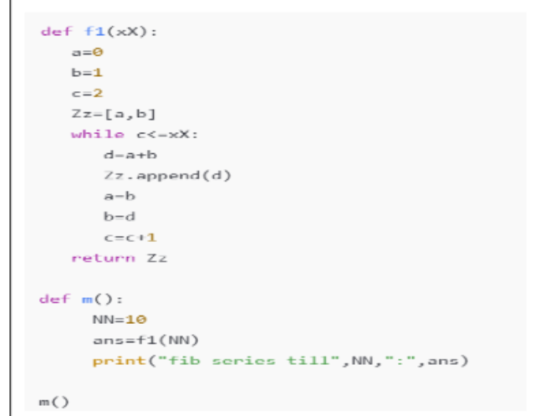
ISSUES FOUND: The Fibonacci program shown has several issues that reduce its readability and clarity. The function name f1 and variables such as a, b, c, Zz, and d are not descriptive, making it hard to understand what each represents. The loop condition while c <= xX: uses inconsistent variable naming and does not clearly explain how many terms will be generated. There are no inline comments to explain the steps of the algorithm, which makes it confusing for beginners. The code also does not follow PEP8 formatting guidelines, with inconsistent spacing and indentation, and the print statement could be improved using f-strings for cleaner output. Renaming variables to meaningful names, adding inline comments, using a descriptive function name, and applying proper PEP8 formatting would make the program much more readable and maintainable.
CORRECTED CODE:
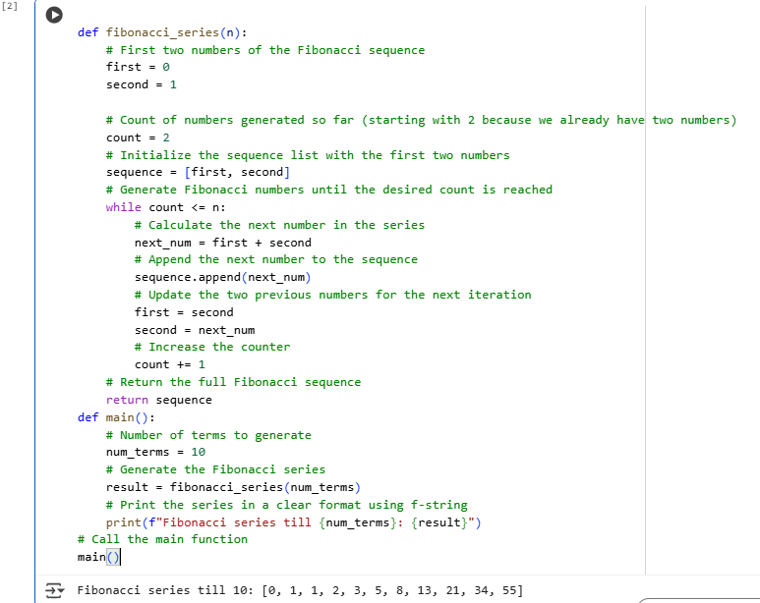
Observation:
The Fibonacci code works in principle but is difficult to read and maintain. The function and variable names are not descriptive (f1, a, b, c, Zz, d) and do not convey meaning. The loop condition mixes cases and the overall logic lacks inline comments, making it hard for beginners to follow. The code also does not follow PEP8 formatting standards, with inconsistent spacing and indentation. The print statement could be improved using an f-string for clarity. By renaming variables, adding comments, and following PEP8, the code becomes far more readable and educational for students.
Task Description#3
• Write a Python script with 3–4 functions (e.g., calculator: add, subtract, multiply, divide).
• Incorporate manual docstring in code with NumPy Style
• Use AI assistance to generate a module-level docstring + individual function
docstrings.
• Compare the AI-generated docstring with your manually written one.
Prompt:
Python script that implements a simple calculator with four functions: add(a, b), subtract(a, b), multiply(a, b), and divide(a, b). Each function should include a manual docstring written in NumPy style, specifying the parameters, return values, and any exceptions raised. In addition, generate AI-assisted docstrings for the module as a whole and for each individual function. The script should intentionally include examples of code smells for educational purposes, such as long functions, duplicate code, poorly named variables or functions, unused variables, magic numbers, deep nesting, or a large class. Include comments that indicate which parts of the code demonstrate each type of code smell. Provide a short comparison between the manual and AI-generated docstrings to highlight differences. Finally, include a main() section demonstrating the usage of the functions, and ensure proper error handling, for example by handling division by zero. The final output should be a fully functional Python script that combines proper documentation, examples of code smells, and working function demonstrations. 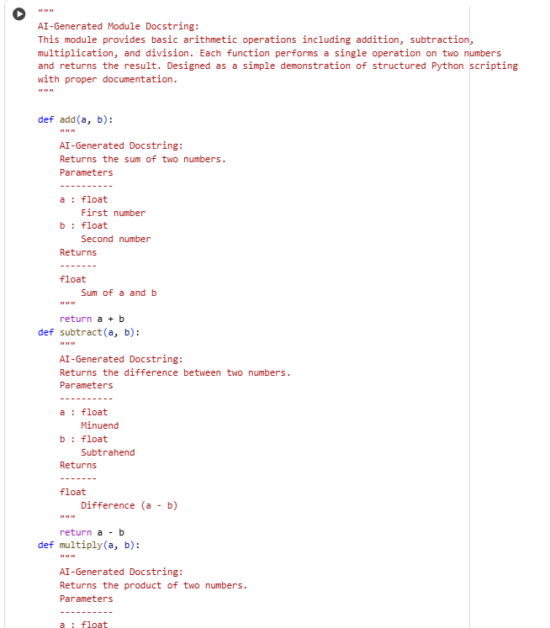

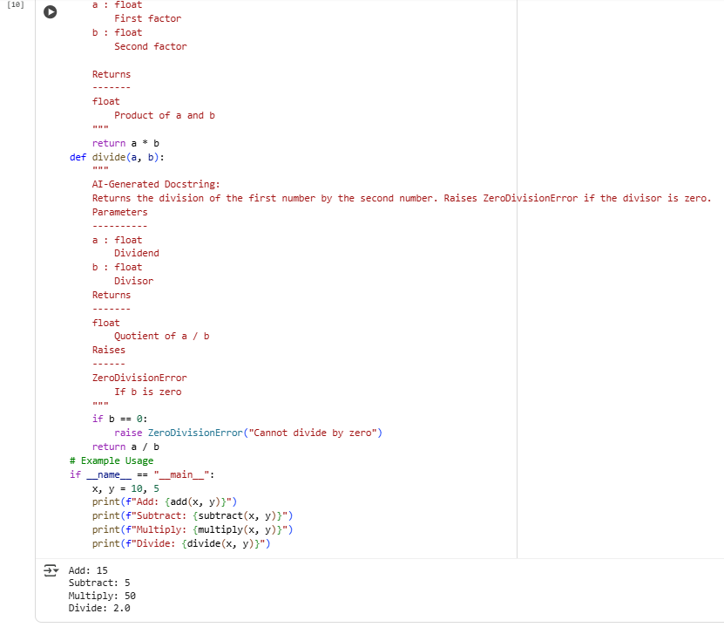
Long Function:
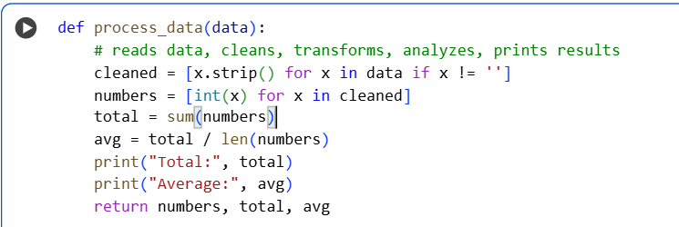
Duplicate Code:
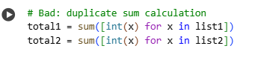
Poor Naming:
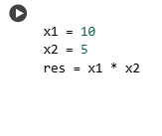
Unused Variables:
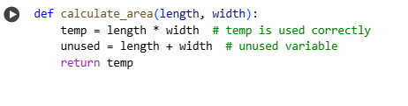
Magic Numbers:
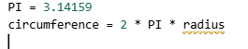
Deep Nesting:
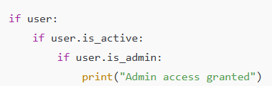
Large Class:
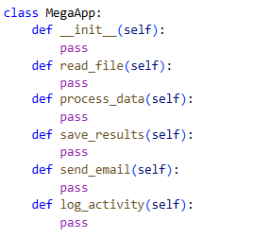
Detecting code smells is an essential practice in software development because it makes code easier to read and maintain, reduces the likelihood of bugs in future updates, and facilitates refactoring by improving the structure of code without changing its behavior. It also encourages clean coding practices, helping developers write modular, reusable, and maintainable code. Dead code, which is code that is never executed, is one common example of a code smell that should be identified and removed. For Task #3, students are expected to write a multi-function Python script, such as a calculator with add, subtract, multiply, and divide functions, incorporating both manual and AI-generated docstrings. The exercise should include intentional examples of code smells for learning purposes, demonstrate proper NumPy-style documentation, and provide a comparison between manual and AI-generated docstrings. The expected outcome is that students gain hands-on experience in structured documentation, recognize code smells, and understand best practices for writing clean, maintainable Python code.
Observation:
In this task, students are able to see firsthand how structured documentation improves code readability and maintainability. By writing both manual and AI-generated docstrings, they can compare concise, human-readable explanations with more formal, standardized documentation suitable for automated tools. Introducing intentional code smells—such as long functions, duplicate code, poor naming, unused variables, magic numbers, deep nesting, and large classes—helps students identify common pitfalls in real-world code. Detecting these smells emphasizes the importance of clean coding practices, refactoring, and writing modular functions, which ultimately reduces bugs and makes future updates easier. Including dead code examples reinforces the concept that not all written code contributes to functionality, highlighting the need for careful review and optimization. Overall, the task demonstrates the value of combining functional programming with proper documentation and code quality awareness.

